Control-A-Flow®

Draft Eliminator

Fineline Ceiling Grid System

Installation Instructions

- The 2 plastic anchors fit inside the hollow portion of the suspension ceiling grid bars. Make sure the flat sides of the anchors face towards the outside edge of the rail, so as it spreads during tightening it pushes against the edge of the T-bar. Push the anchors one at a time into the grid bar grooves. Use a Philips head screwdriver to tighten down the anchors. Not too tight, as you don’t want to crack the rail. If the anchors do not snap in easily, loosen the screw until the anchor can snap into the groove, and then tighten.
- Each panel needs 2 self-adhesive silicone pads (enclosed) placed on the non-printed side at the very end of the panel, directly over the metal rod inside the panel. These are used to prevent the panels from being moved off the rails.
- With the pads facing up, put one panel into a rail slot, close to the end of a rail. Flex the opposite rail outwardly and fit the panel stop past the rail stop. Slide this panel to the otter end and repeat.
- By using the “Adjusting Wand” you can now adjust your Control-A-Flow panels and rails cover plate to create air flow in 2, 3, 4 or 5 directions, while safely standing on the floor.

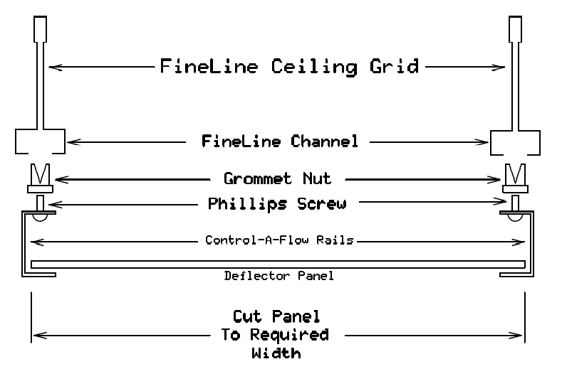

Parts List

- 2 each translucent panels – 12" x 24.25" (cut to width needed)
- 2 each 32" rails with fine line grommet, screw and cover plates attached
- 1 each “Adjusting Wand”
- Set of 4 stop pads Rail Color – Soft White

